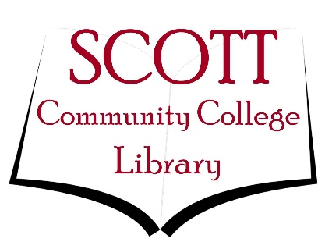

Free Online Open Educational and eBook Resources

OERs
The websites listed below are Open Educational Resources (OERs) that may include texts and readings relevant to your courses.
OERCOMMONS.org
https://open.umn.edu/opentextbooks
http://opencourselibrary.org/
https://www.merlot.org/merlot/
https://openaccessbutton.org/

eBooks
Listed below are websites with free eBooks that can be read in a variety of formats, including web browsers and in Kindle software.
https://www.gutenberg.org/
https://about.muse.jhu.edu/muse/open-access-overview/

