All EICC staff, students, and instructors,

Beginning January 2023, all current staff, students, and instructors will have institutional access to the New York Times newspaper.

To get started, you will need to visit the following link and sign-up using your eicc.edu or live.eicc.edu email account assigned by Eastern Iowa Community Colleges.

https://eicc.idm.oclc.org/login?url=https://ezmyaccount.nytimes.com/grouppass/redir

Once there, you will choose your status-student, faculty/staff, or other. Students will be required to add an estimated year of graduation.

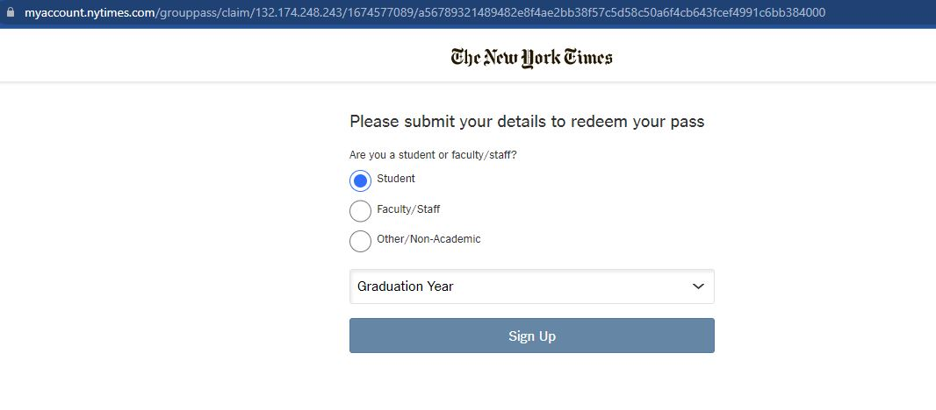
From there, based on your status, you will be prompted to create your account and can also set a reminder when it is time to renew the academic pass. Those users with an eicc.edu email have a three year subscription. Those persons with a live.eicc.edu address will need to renew their academic pass each year.

If you currently have a paid, private subscription to the New York Times, you must contact the help desk at the New York Times and either call, email, or chat with a representative to cancel your account. They can’t transfer over another account into our institutional account. If you currently pay for a subscription using your eicc.edu email or live.eicc.edu email you will need to cancel that subscription PRIOR to registering for the institutional account.

When you visit the New York Times, you will log in with your College email and the password you created by clicking in the upper right [Log In].
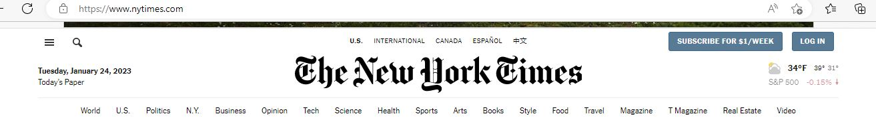

This newspaper subscription was paid for with EICC Libraries funding. If you have questions, please feel free to contact the EICC Libraries.

It is the policy of Eastern Iowa Community College District not to discriminate in its programs, activities, or employment on the basis of race, color, national origin, sex, disability, age, sexual orientation, gender identity, creed, religion, and actual or potential family, parental or marital status, as required by the Iowa Code §§216.6 and 216.9, Titles VI and VII of the Civil Rights Act of 1964 (42 U.S.C. §§ 2000d and 2000e), the Equal Pay Act of 1973 (29 U.S.C. § 206, et seq.), Title IX (Educational
Amendments, 20 U.S.C. §§ 1681-1688), Section 504 (Rehabilitation Act of 1973, 29 U.S.C. § 794), and Title II of the Americans with Disabilities Act (42 U.S.C. § 12101, et seq.). If you have questions or complaints related to compliance with this policy, please contact EICC’s Equal Employment Opportunity Officer/Equity Coordinator, Eastern Iowa Community College District, 101 West Third Street, Davenport, Iowa 52801, 563-336-5222, equity@eicc.edu or the Director of the Office for
Civil Rights U.S. Department of Education, John C. Kluczynski Federal Building, 230 S. Dearborn Street, 37th Floor, Chicago, IL 60604-7204, Telephone: (312) 730-1560 Facsimile: (312) 730- 1576, TDD (800) 877-8339 Email: OCR.Chicago@ed.gov.

