Rhetorical Context
Rhetorical context refers to the circumstances surrounding an act of reading and/or composition. Rhetorical context includes:
- the author
- the author’s purpose for composing
- the topic
- the audience
- the occasion, or external motivation, for composing
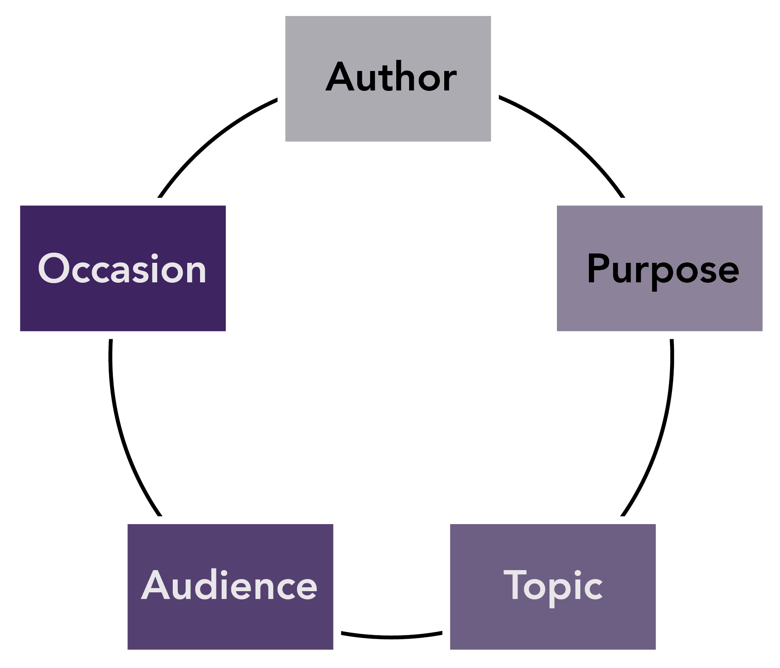
Lumen Writing Skills Lab: https://courses.lumenlearning.com/wm-writingskillslab-2/chapter/rhetorical-context/

