Narrative Writing

PURPOSE
The purpose of a personal narrative is to tell the audience a story from which the reader learns something from your experience. It can be written to motivate, educate, or entertain.

Ultimately, narrative writing tries to relay a series of events in an emotionally engaging way. You want your audience to be moved by your story, which could mean through laughter, sympathy, fear, anger, and so on. The more clearly you tell your story, the more emotionally engaged your audience is likely to be.

The challenge in writing a good narrative is to captivate the audience and keep them engaged as the story is told.

Writing an Impactful Personal Narrative Essay
A personal narrative essay is about a personal experience, so it is usually written in the first person. To maximize its impact, the essay should:
- Be written to have an emotional impact on the reader
- Create a sense of shared experience with the reader
- Include a lot of references to sensory perceptions and emotions
- Use vivid details and imagery
- Include only details that support the purpose/theme of your essay
- Use chronological order
- Highlight the most crucial moments
- Use storyline elements (setting, characters, plot, climax, etc.)
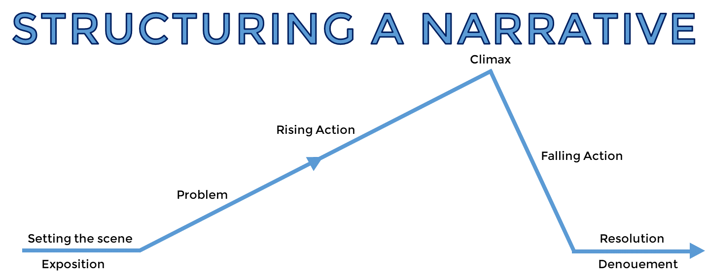
*ALTHOUGH NARRATIVES CAN TAKE MANY DIFFERENT FORMS AND CONTAIN MULTIPLE CONFLICTS AND RESOLUTIONS NEARLY ALL FIT THIS STRUCTURE IN WAY OR ANOTHER.
STRUCTURE
ORIENTATION (BEGINNING)
Set the scene by introducing your characters, setting and time of the story. Establish your who, when and where in this part of your narrative
COMPLICATION AND EVENTS (MIDDLE)
In this section, activities and events involving your main characters are expanded upon. These events are written in a cohesive and fluent sequence.
RESOLUTION (ENDING)
Your complication is resolved in this section. It does not have to be a happy outcome however.

*While these are the agreed norms for a narrative, there are numerous examples of popular texts that did not explicitly follow this path.

